Disney Files Patent for Star Wars Hotel Room Immersive Multimedia Experience
By
Mike April 12, 2018

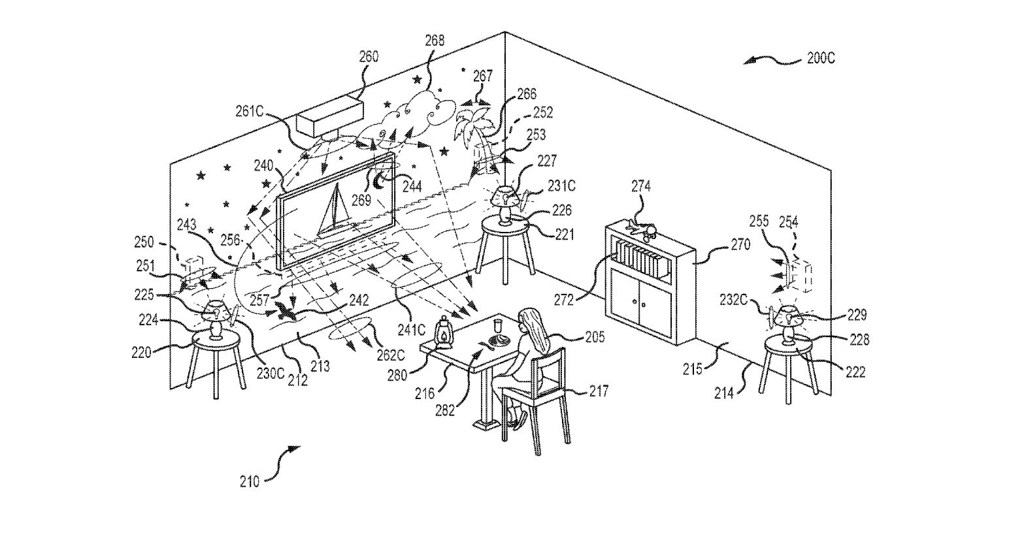
With the recent filing with the state of Florida to explore land adjacent to Star Wars: Galaxy’s Edge, Disney has now filed a patent for what they’re calling a MULTIMEDIA SYSTEM FOR TRANSFORMING ANY ROOM INTO A SHOW ENVIRONMENT. In layman’s terms, Disney is trying to patent a system that will transform any room into a show environment via the means of digital and physical systems. The abstract for the patent, in part, is as follows:
The in-room show system generally includes a controller for selectively operating a display device (e.g., a television or the like), a video projector, an audio system (e.g., one or more speakers), and other show components (e.g., one or more lights, a fan, a mechanical device, and so on). Media content is predefined for the room, and the controller operates (such as in response to a triggering switch or remote control device that may take the form of a show prop activated by someone in the room) to serve the media content to tell a story and/or magically transform the space into a multidimensional and immersive entertainment space.
The patent goes on to list projection mapping, surround sound audio, independent lighting systems, projectors, show components, fans, and other physical effects.
Disney has also included multiple diagrams that show a room coming to life around a guest via digital and physical systems. Here are a few of the patent drawings.
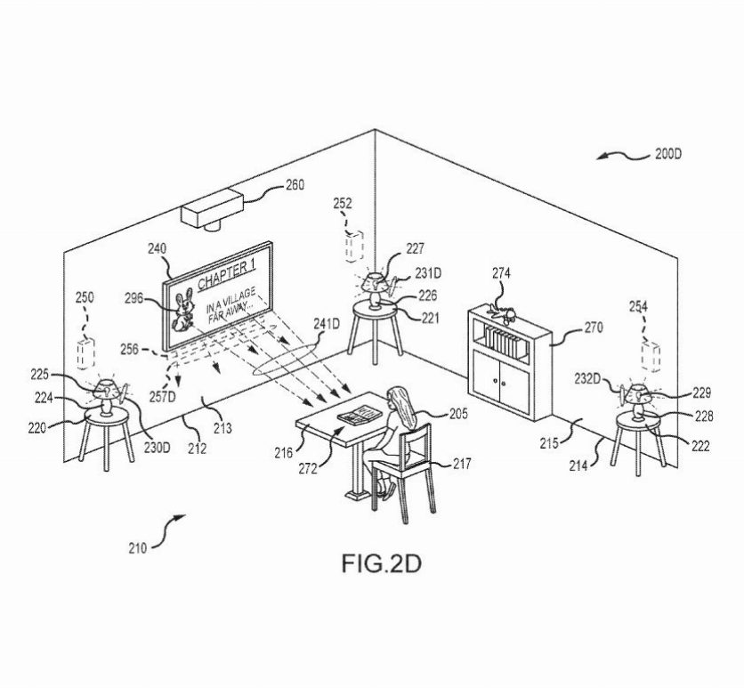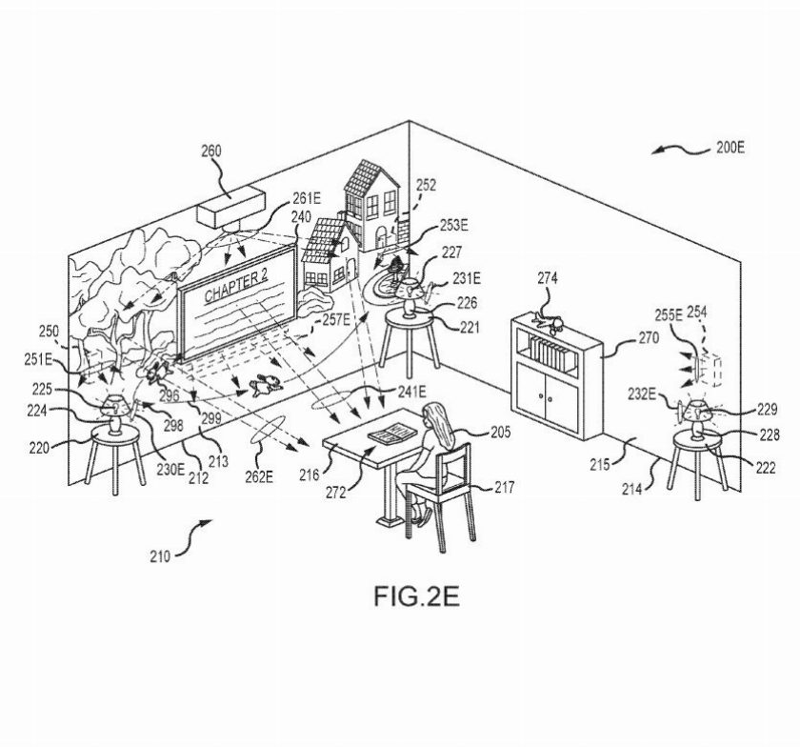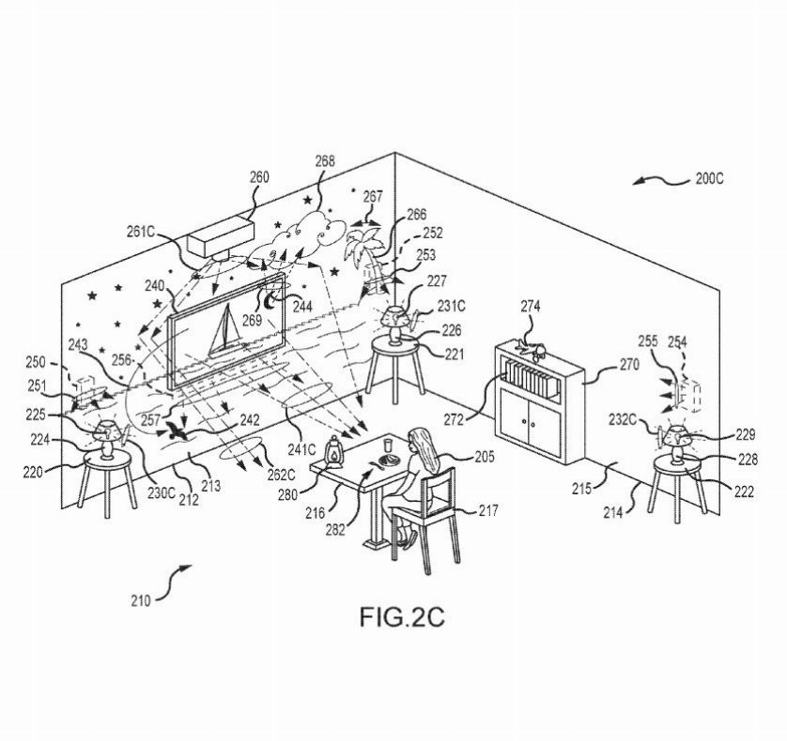
While the patent keeps the usage broad (“a room defined by one or more walls”) we will definitely see this type of technology used in the upcoming Star Wars hotel.
Here’s some concept art put out by Disney of the new hotel.
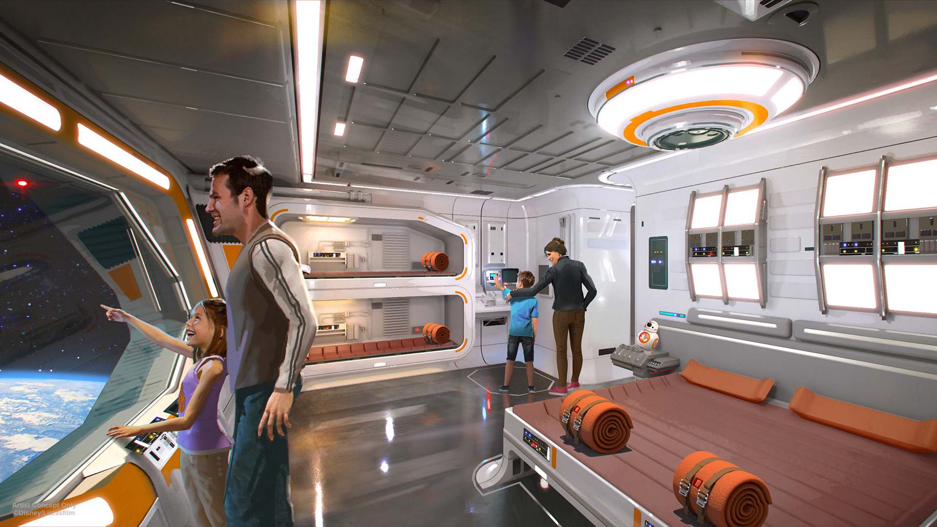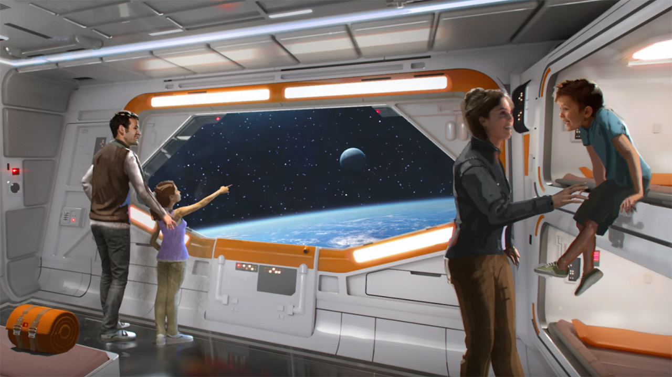
Disney has yet to announce an opening date or time frame for the Star Wars hotel.

