21 Things I learned-Makerspace

ReMaking Education:Creating Makerspaces in Schools

What’s a Makerspace?

Agree or Disagree?

Makerspaces represent the democratization of design, engineering, fabrication and education.

Defining Makerspaces:

Agree or Disagree?
A woodshop is a “real makerspace” because it has power tools.
Some makerspaces are more valid than others and that a makerspace is solely defined by the tools it contains.
Q:
Is my space any less of a makerspace simply because it doesn’t have power tools? Because it doesn’t have a 3D printer?
Q:
What if my students build with LEGOs, K’nex and cardboard?
Here’s my own definition of a school Makerspace:

A Makerspace is a place where students can gather to design, create, invent, tinker, explore, build, fail, discover and reflect using a variety of tools and materials.

What I learned about Makerspaces
- A Makrspace can be anything from a repurposed bookcart filled with arts and crafts supplies to a table in a corner set out with LEGOs to a full blown fab lab with 3D printers, laser cutters, and hand tools.
- “Makerspaces are collaborative learning environments where people come together to share materials and learn new skills… makerspaces are not necessarily born out of a specific set of materials or spaces, but rather a mindset of community partnership, collaboration, and creation.
- No two school makerspaces are exactly alike, nor should they be.
- Makerspaces are as unique as the school cultures they represent.
- There is no such thing as one form of making being more valid or better than the other.
- Makers are artists, crafters, knitters, seamstresses, builders, programmers, engineers, hackers, painters, woodworkers, tinkerers, inventors, bakers , graphic designers and more.
- The word Makerspace is a general term for a place where people get together to make things.
- Really cool things happen when makers combine materials and ideas from different kinds of skills and tools.
- The kinds of tools found in makerspaces reflect the interests of the community.
- A makerspace is a physical location where people gather to share resources and knowledge, work on projects, network, and build.
- Makerspaces are not about the tools; they’re about enabling making.
- A space where kids have the opportunity to make – a place where some tools, materials, and enough expertise can get them started.
- In effect, a makerspace is a physical mash-up of different places that allows makers and projects to integrate these different kinds of skills.” Dale Dougherty, The Maker Mindset, in Design, Make, Play
- “Even if you don’t have access to expensive… hardware, every classroom can become a makerspace where kids and teachers learn together through direct experience with an assortment of high and low tech materials.” ~ Gary Stager and Sylvia Martinez in Invent to Learn
- The most important quality of a makerspace is that it encourages creativity.
- Make Things that you are curious about and spring from your imagination.
- Make Things that inspire you and things that you admire.
- The informal, playful atmosphere allows learning to unfold, rather than conform to a rigid agenda.
- Making, rather than consuming is the focus. It is craft, engineering, technology and wonder-driven.
- The culture in a space should support the idea that anything is possible.
- “Makerspaces provide hands-on, creative ways to encourage students to design, experiment, build and invent as they deeply engage in science, engineering and tinkering.
Question To Ask
Goals of a Successful School Makerspace

What are the goals of this Makerspace?
Are you focused on getting students to exercise their creativity? To learn about electronics hands-on? To design and prototype their own creations? To practice engineering skills? While a Makerspace can do all of those things, some people want to focus on one domain more than another. Some are focused on providing exposure to technologies that students would never see otherwise. Some are more interested in creative expression through crafts and DIY. Both are valid.

What does my school already have?
The needs of a 1:1 school or a school where every single student has some type of device are going to be different from a school that doesn’t have functional wi-fi. Your library might already have an iPad cart. Your school might already have a robotics team or woodshop. Your science department might have bins of K’nex that they bought years ago that are just sitting around. These need to be considered as you put together your Makerspace proposal.

How much physical space do I have?
While the dream would be to have a dedicated room, most schools don’t have this much space. My growing Makerspace is one corner of the library. Some schools don’t even have that much. Consider how much room you have for supplies and where you’ll store them when not in use. There’s no sense in getting a ton of stuff if there’s nowhere to put it. Many schools are putting together Makerspace carts that can be put away when not in use.

How will it be used?
Will it be a mobile Makerspace that travels? Will classes come specifically to use it? Is it geared towards students who have a little free time? Or will there be a Maker Club? All of these need to be considered when figuring out what you will get. If it’s a drop-in-when-you-have-free-time Makerspace, LEGOs and LittleBits will be easier for students to use than a bunch of Arduino’s and soldering irons. If there will be a specific, regular group, more in-depth projects can work better.

Where will I get the supplies?
There’s so many different ways to outfit your Makerspace. You’re likely to have more success trying to get a few things at a time than writing a $10,000 grant. Focus on smaller grants, DonorsChoose projects, bookfair profits, etc. Also, see what you can get donated. Many stores are willing to donate broken electronics for a tech-take-apart station. Parents may have LEGOs sitting around their house that they’d be happy to give to the school.

School Makerspace Student Goals

From Wade Gegan – Edited by Dr. Howie

The challenge of Makerspaces and creativity is effectively cultivating and harnessing it to its fullest. Laying a foundation for innovation will allow everyone to take full advantage of what a well-planned makerspace can provide. “A simple makerspace that sparks the hearts and minds of students will invariably succeed whereas a fully adorned makerspace that lacks that spirit is certain to fail.”

Each of the below goals can assist in maker activities to ensure that more than just play is happening in the space. While of course play should be encouraged, and is a hugely important ingredient to making, these nine goals will help you put together a school makerspace that is not only fun and enjoyable, but one that is deeply productive and meaningful.

School Makerspace Student Goals
- Use a wide range of idea creation techniques – such as brainstorming
- Create new and worthwhile ideas – both incremental and radical concepts
- Elaborate, refine, analyze and evaluate their own ideas in order to improve and maximize creative efforts
- Develop, implement, and communicate new ideas to others effectively
- Be open and responsive to new and diverse perspectives; incorporate group input and feedback into the work
- Demonstrate originality and inventiveness in work and understand the real-world limits to adopting new ideas
- View failure as an opportunity to learn; understand that creativity and innovation are a long-term, cyclical process of small successes and frequent mistakes
- Implement innovations
- Act on creative ideas to make a tangible and useful contribution to the field in which the innovation will occur
- REFLECTION

Everyday Makerspaces:

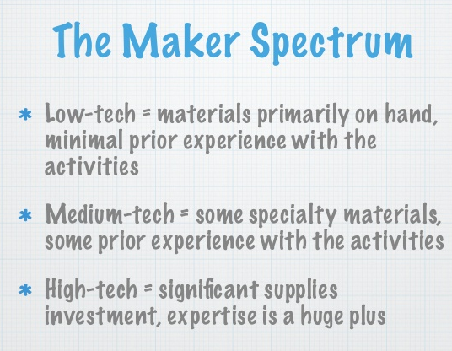
Low-Tech - Medium Tech-High Tech
Amy Koester- Librarian
at St. Charles City-County Library District

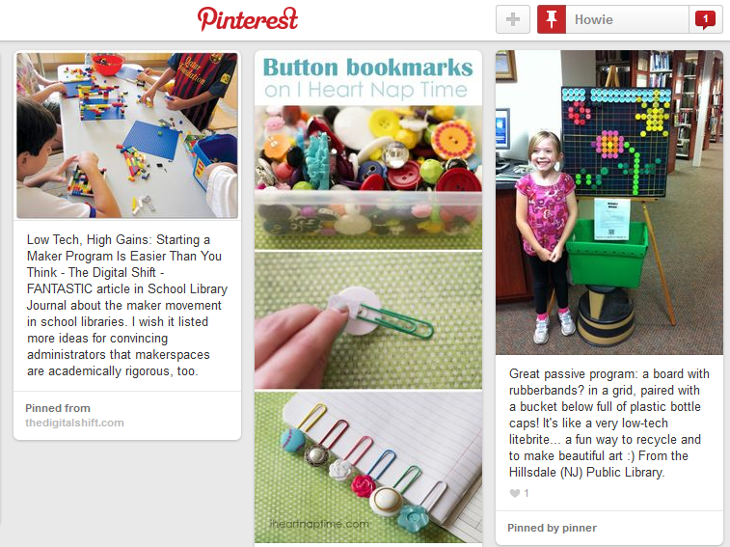
Low-Tech Maker Space Ideas

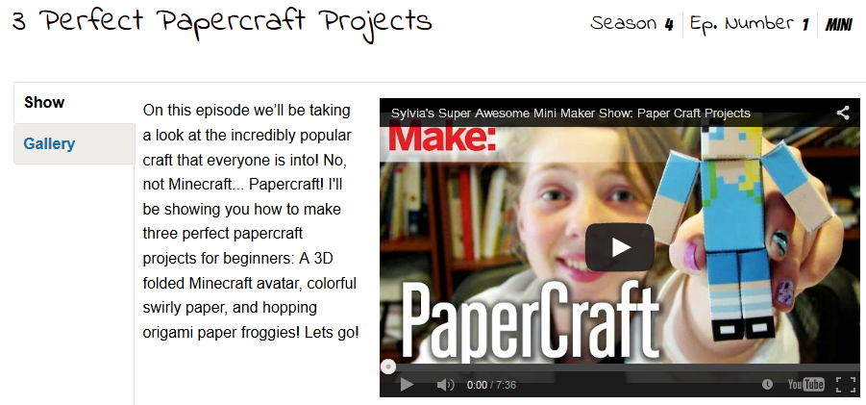

SketchUp.com - SketchUp 2015 is Here‎
Request a full-featured, no-cost SketchUp Pro license


Medium – Tech
Getting Started With Scratch - MIT
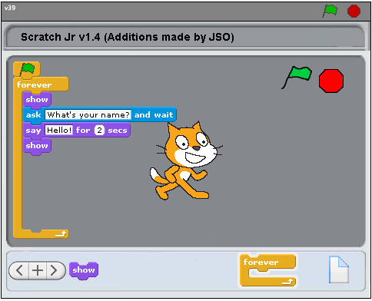

App Lets Kids Create, Customize Video Games
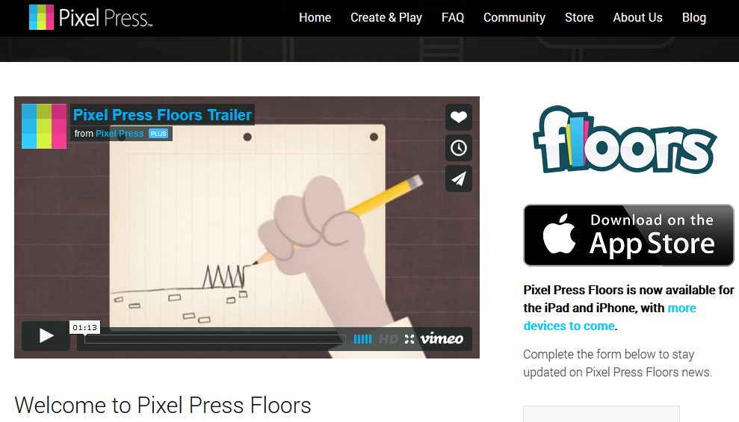

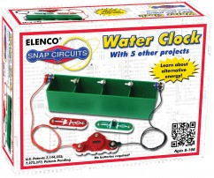
Welcome to Snap Circuits
by Elenco
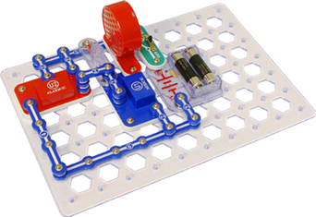

Can Raspberry Pi transform IT education?
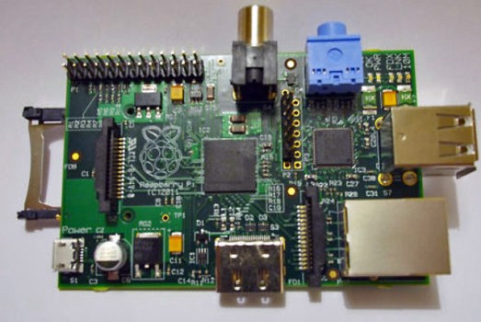

- $25 Raspberry Pi – a basic computer on a single printed circuit board
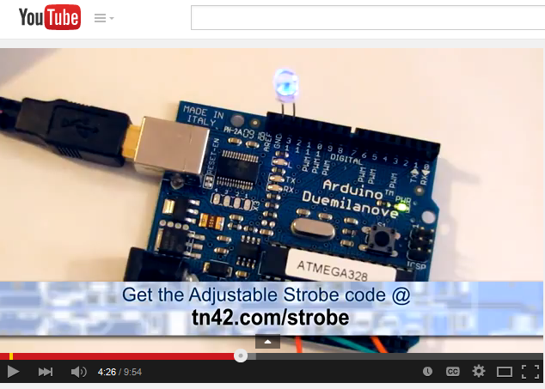
Super Simple Arduino - Sylvia's Super-Awesome Maker Show:
https://www.youtube.com/watch?v=3xCY2K9kQz4

Mirobot: An Affordable WiFi Robotics Kit
http://mirobot.io/
Mirobot - the WiFi drawing robot kit
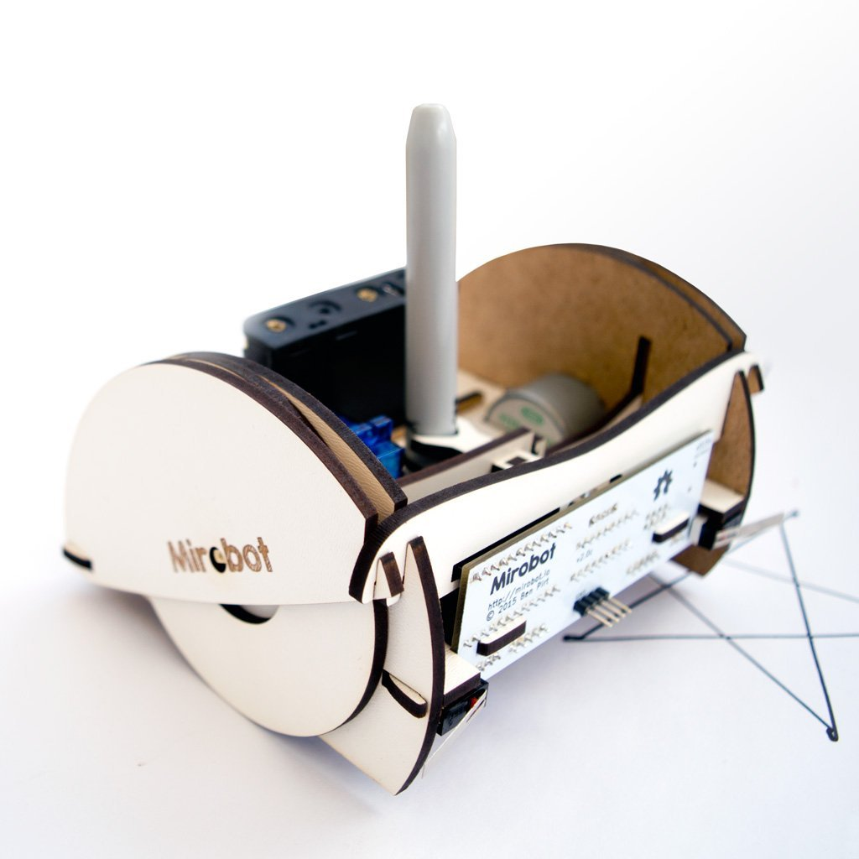
Price:$75.00 & FREE Shipping. Details

Investing in a school’s first 3D printer may be a down payment on the future of education
Gary Stager
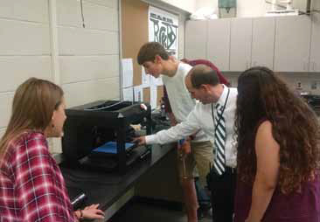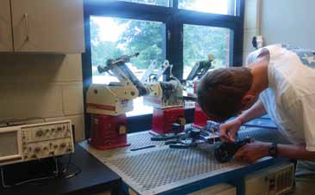

Top Five 3D Printers under $500
• 1 XYZ Printing Da Vinci 1.0
• 2 PrintrBot Simple Maker Edition Kit
• 3 Solidoodle 2 Pro
• 4 Buccaneer 3D Printer
• 5 QU-BD One Up
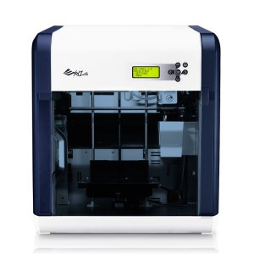
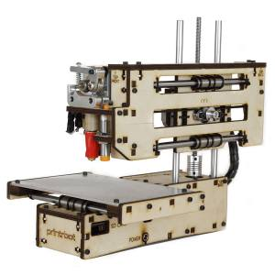

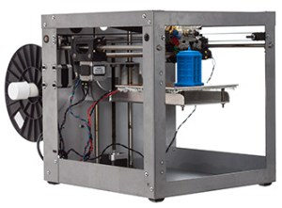
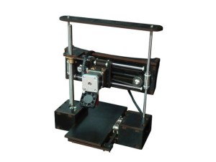

High Tech
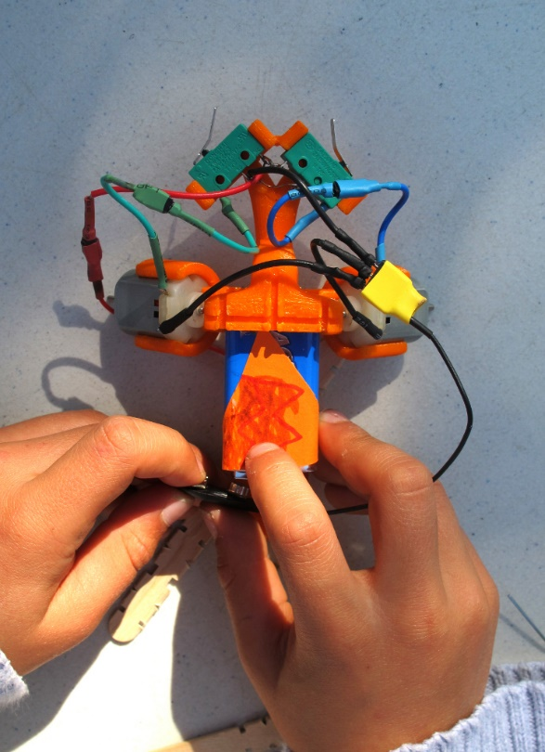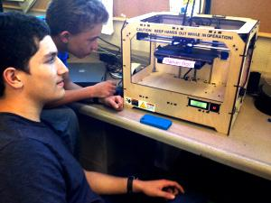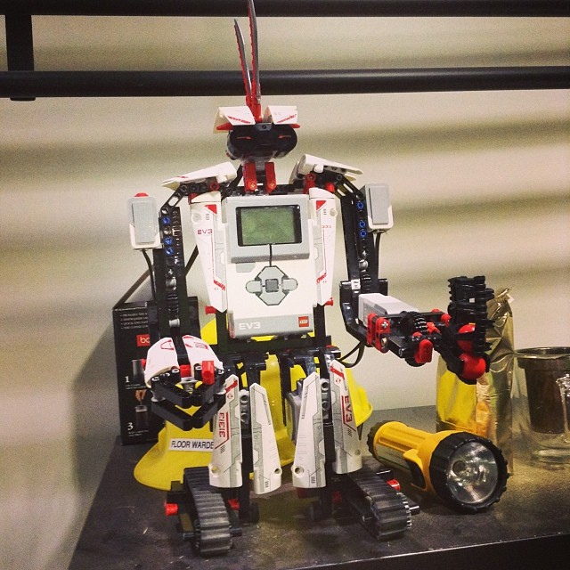

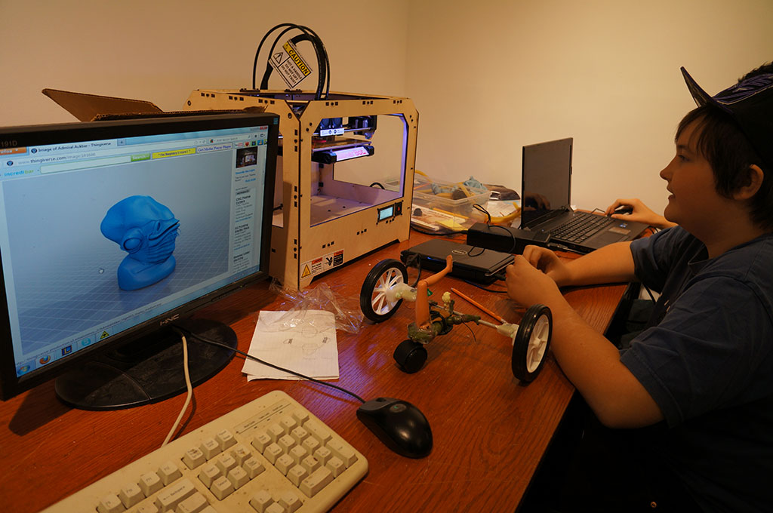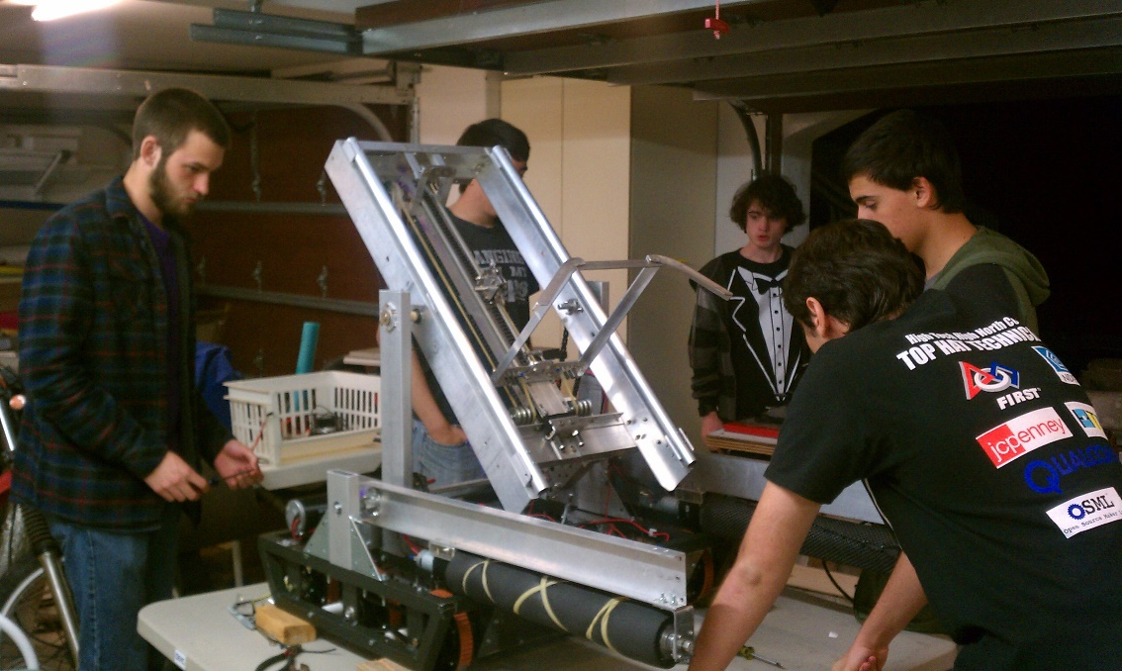

24 Unique Maker Education Resources For Teaching & Learning
by Mike Acedo
- 1. http://makezine.com/
- 2. http://www.raspberrypi.org/
- 3. http://makerfaire.com/
- 4. http://youngmakers.org/ & http://makered.org/
- 5. http://www.instructables.com/index
- 6. http://makerspace.com
- 7. http://curriculum.makerbot.com/
- 8. http://www.thingiverse.com/
- 9. http://learn.adafruit.com/
- 10. http://web.media.mit.edu/~emme/guide.pdf
- 11. https://learn.sparkfun.com/curriculum
- 12. http://tinkering.exploratorium.edu/ & http://blogs.exploratorium.edu/tinkering/
- 13. https://diy.org/
- 14. http://cardboardchallenge.com/
- 15. http://catalyst-academy.org/course/make-hack-play/
- 16. http://www.businessinnovationfactory.com/projects/sxl/lab-news/student-designer-how-kit-now-available
- 17. http://blog.nwp.org/clmooc/makes/
- 18. http://makeymakey.com/
- 19. http://www.howtoons.com/
- 20. http://stager.org/articles/goodpbl.pdf
- 21. http://m2l.indiana.edu/
- 22. http://littlebits.com/
- 23. http://glasslabgames.org/
- 24. Minecraft.print

Places to Look for Project Ideas (from Maker Ed Initiative website)
- Adafruit has tutorials that cover topics such as electronics and Arduino micro controllers, and The Adafruit Learning System.
- Instructables has user-submitted illustrated guides to a wide range of projects
- Make: Projects is a curated site of projects (also, the Kids and Family section of the Make: blog has projects specifically aimed at young makers)
- Makerbot has curriculum for using 3D printing in classes
- The MENTOR Makerspace program’s guide for creating a makerspace in high schools
- The MIT Media Lab’s High Tech Low Tech group’s workshop facilitator’s guide for soft circuits
- Sparkfun has a curriculum page with beginner/intermediate and advanced projects
- The Young Makers program’s playbook for creating a Young Makers club
- The Exploratorium‘s Tinkering Studio has a wealth of articles, activities, and an active blog
- DIY.org has a growing number projects and challenges, and the ability to share project photos.
- Hackaday is a platform for people who like to hack things for the better.
- e-textiles http://jennyschu.blogspot.com/2011/10/etextiles-pac-man-bangle.html
- Why Reef; A virtual coral reef created by scientists at Chicago’s Field Museum of Natural History allows kids to “dive” on two reefs http://fieldmuseum.org/schools/whyreef
- Hive Learning Network http://hivelearningnetwork.org/
- Gardening Ideas
  - R&DIY; Collaborative gardening/build-it-yourself website
  - http://www.rndiy.org/
  - http://our.windowfarms.org/instructions_dev/
- Straw Bale Gardens http://strawbalegardens.com/
Game Development Stuff
- GoGoLabs - Shake it Up Learning http://gogolabs.net/
- MIT Game Lab - A Slower Speed of Light http://gamelab.mit.edu/games/a-slower-speed-of-light/
- iCivics; An online game and platform that engages students in learning about the three branches of government and other civics information http://www.icivics.org/
- Review of Super Scratch Programming Adventure!: Learn to Program by Making Cool Games
Stealth Programming
- PoetTree idea http://www.libraryasincubatorproject.org/?p=4160
- Google doc chock-full of ideas from June 2012 https://docs.google.com/document/d/1OBGwr9qm39WZ8s-l9tTNB5uNbQTC-Cel_G43...
- ReUse Cup Challenge http://www.interiordesignersofidaho.org/chair-affair/reuse-cup-challenge/
- Fantastically Cool Photo Challenges--easy to replicate http://content.photojojo.com/guides/photography-games/
- Stealth Programming Blog: http://www.abbythelibrarian.com/2009/08/passive-not-aggressive.html
- Book on Stealth Programming: http://www.amazon.com/Librarians-Guide-Passive-Programming-Affordable/dp...
- Articles on passive, stealth, pro-active or DIY programming http://www.libraryasincubatorproject.org/?p=2512
Competitions, Contests, and Maker Events
- National STEM Video Game Challenge http://stemchallenge.org/
- Tech Soup-Digital Storymaking challenge http://www.techsoupforlibraries.org/blog/techsoup039s-digitoolbox-for-di...
- Imagine Cup; Microsoft http://www.imaginecup.com/#?fbid=Cj6Lyeh9ujF
- Future City Competition http://futurecity.org/idaho
- Mars Rover Challenge: http://id.spacegrant.org/index.php?page=idaho-tech
- FIRST Tech Challenge http://www.usfirst.org/roboticsprograms/ftc
- National Girls Collaborative Project; Encouraging girls to pursue careers in Science, Technology, Engineering, and Mathematics http://www.ngcproject.org/
- Project Connect: Digital Media and Learning Competitions http://hastac.org/competitions/
- Click!Online: Girls Solve STEM Mysteries at Spy School http://www.clickspyschool.org/
- MakerFaires http://makerfaire.com/

