15 Things NOT To Do In Paris

It's impossible to see and do everything when visiting Paris, so why waste time doing anything that isn't worthy of your hard-earned vacation hours? The next time you're in the City of Light, don't fight with crowds in tourist traps, eat at the wrong restaurants, or wait in line at the Eiffel Tower. Including a list of the best museums to visit and information on how best to plan your visit, this expert advice will let you actually enjoy the city and make your vacation one to remember.
By Jennifer Ladonne
- DON'T EAT AT THE FAMOUS BRASSERIES
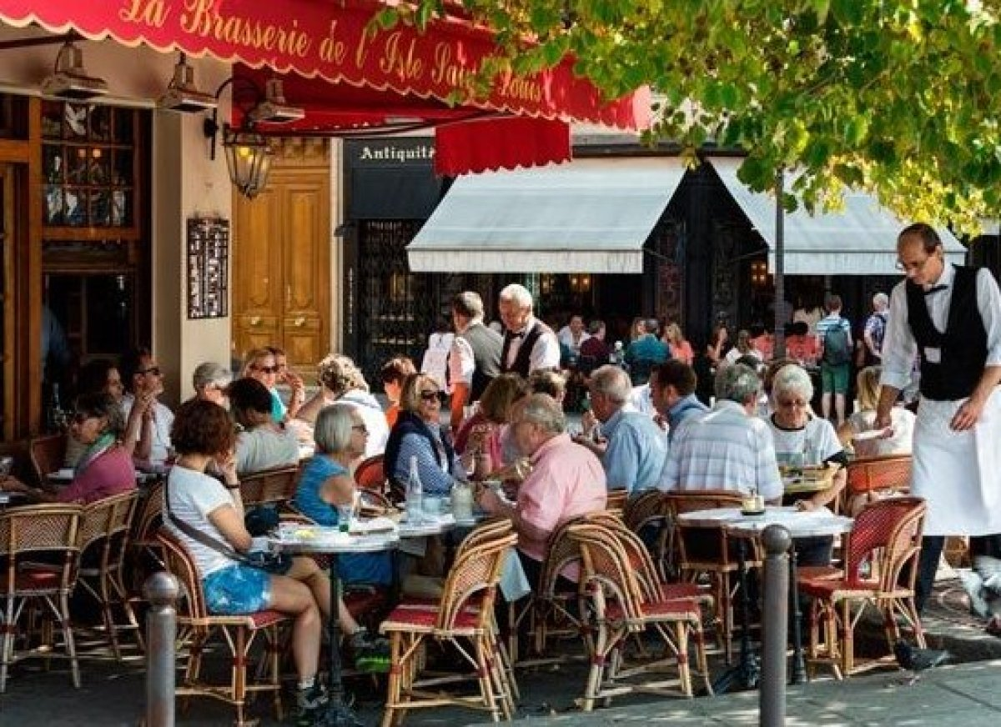
Photo Credit: wjarek / Shutterstock Full of history and charm, Paris's legendary brasseries are definitely worth a visit, and all-day hours make them convenient for a quick bite anytime. But you don’t necessarily want to splurge on a meal at a one of the brasseries. It's an unfortunate fact that Paris's big-name brasseries are now often run by chains cashing in on their fame, and the quality-to-price ratio varies drastically from one to the next. A beer or chocolat chaud at La Coupole, Bofinger, the sublime Le Grand Colbert, or Brasserie Lipp, for example, is a great idea. But for a truly French sit-down meal, La Palette, in the heart of Saint-Germain-des-Prés,Le Chardenoux (11th), Terminus Nord, across from the Gare du Nord (10th), and if you're feeling flush, Drouant, deliver on every front and then some. For some over-the-top fun, the newly restored Le Train Bleu, inside Gare de Lyon, is as spectacular as it gets. Plan Your Trip: Visit Fodor’s Paris Travel Guide
- DON'T LIMIT YOURSELF TO THE GRANDS MAGASINS
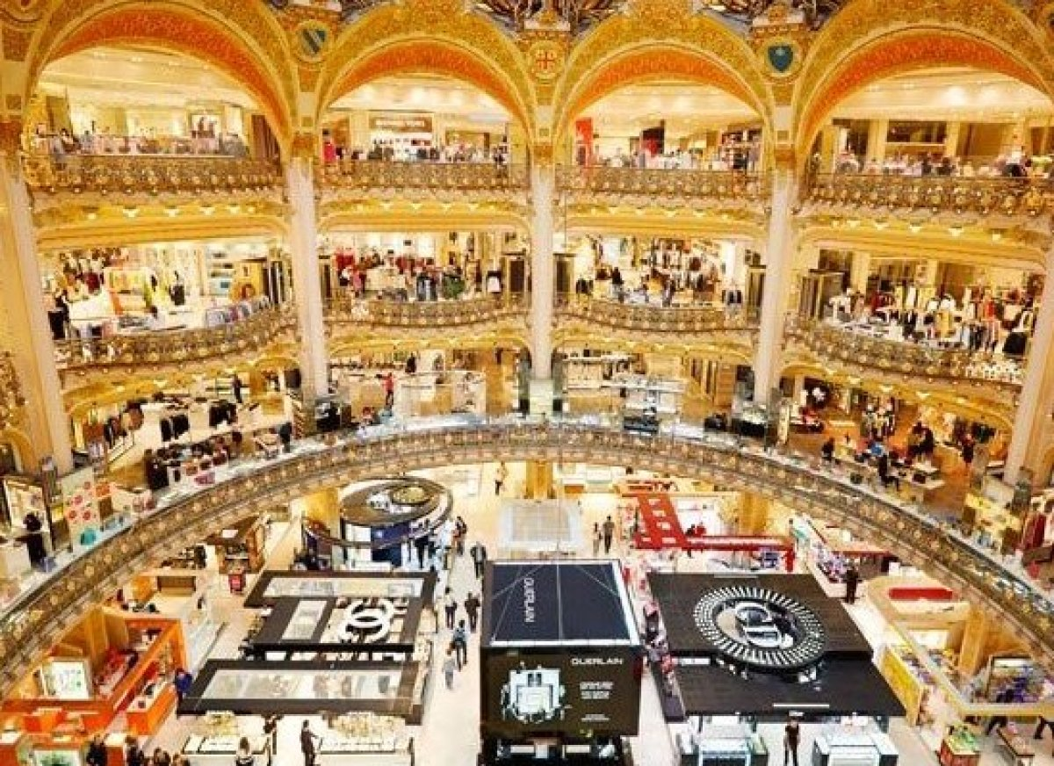
Photo Credit: andersphoto / Shutterstock In a pinch, you'll find pretty much everything you could possibly need or want at these historic (and huge) department stores, but you'll have to contend with impersonal service and crowded spaces, especially at sale times (late June–July; first week of January on). Paris is known for its many fabulous shopping neighborhoods and enclaves, full of unique boutiques and oh-so-Parisian treasures. The Marais, Saint-Germain-des-Prés, the Golden Triangle (Avenues Montaigne, George V, Champs-Elysées), and the Rue Saint-Honoré are the city's most famous and plentiful, but there are scores of streets ripe for discovery: rues Charonne and Keller; the wonderful old market streets Rue des Martyrs and Montorgueil, and Montmartre; the peerless Palais Royal; rue Vavin for kids clothing; and rue Beaurepaire near Canal Saint-Martin. Plan Your Trip: Visit Fodor’s Paris Travel Guide
- DON'T PLAN ANY MEALS IN TOURIST AREAS
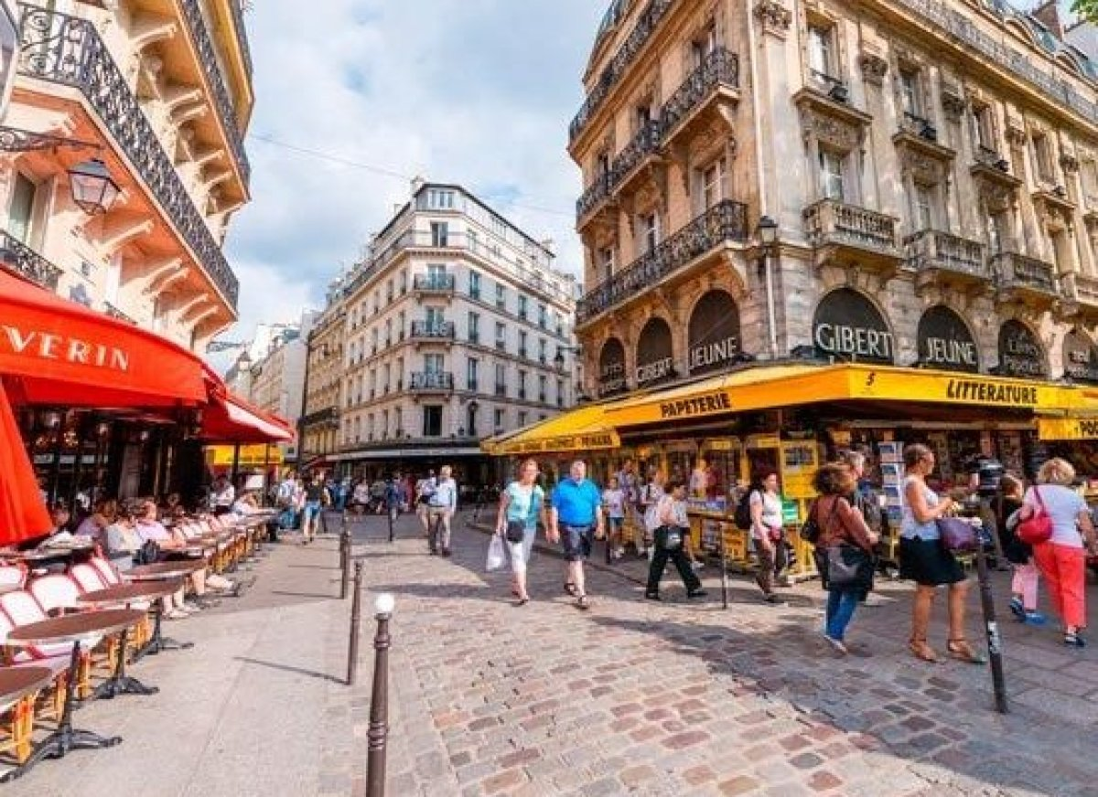
Photo Credit: CristinaMuraca / Shutterstock In general, the Place du Tertre in Montmartre, the Latin Quarter, the area around Notre Dame, the Louvre, the Eiffel Tower, and other places where tourists are plentiful are a big no-no. With so many good places to eat in Paris—plenty of them within easy walking distance of tourist areas—it's a shame to waste money on substandard dining. Do your homework ahead of time with a good Paris restaurant guide or website and be prepared to scout out eateries and cafés that aren't catering only to tourists. Alternatively, visit one of Paris's many wonderful épiceries (small specialty grocers), found in every arrondissement, for prepared foods to-go. Or simply grab a baguette and some cheese—et voilà! Instant picnic. Plan Your Trip: Visit Fodor’s Paris Travel Guide
- DON'T SKIP THE SMALLER MUSEUMS
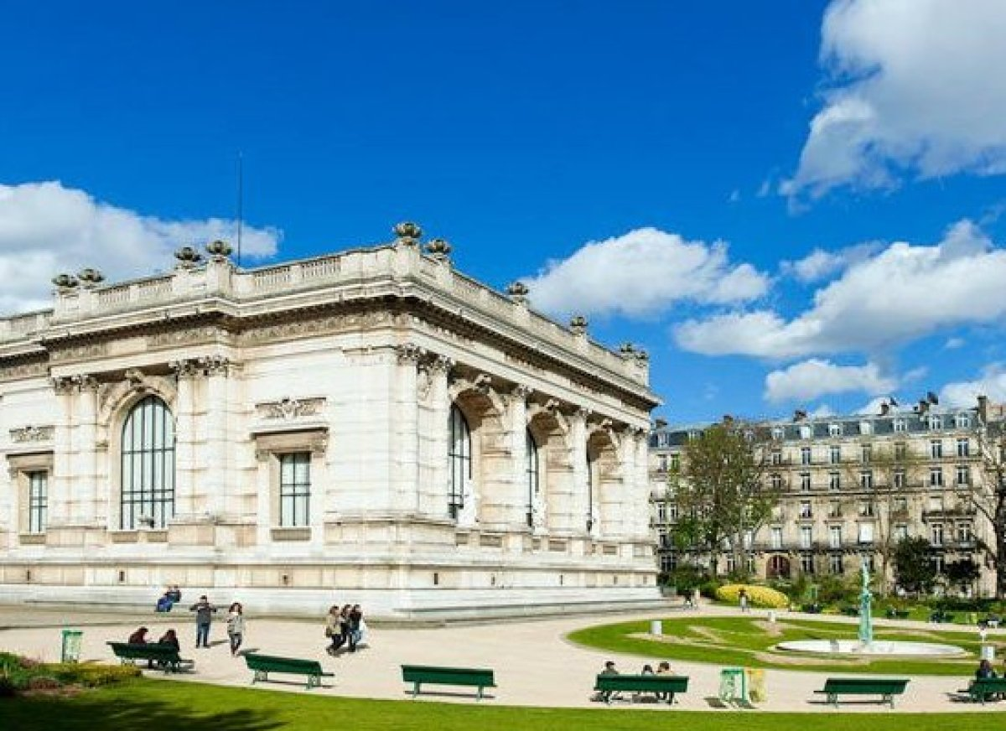
Photo Credit: Paris Tourist Office / Daniel Thierry Paris is a treasure trove for small, gem-like museums, many of them at one-time private mansions that remain exactly as they were when the inhabitants, famous or not, lived there. The list is long:Jacquemart André, Gustave Moreau, Nissim de Camondo, Cernuschi, Musée de la Vie Romantique, Cognacq-Jay, Dapper, the Palais Galliera for fashion, and many more. Don't forget the mid-size museums, like the Musée Carnavalet (the museum of the city of Paris), where you'll find Marcel Proust's actual bedroom; and the excellent Musée Guimet and its little-known offshoot, exquisite Musée d'Ennery. Many of these museums are run by the City of Paris and therefore free to the public. And on the first Sunday of the month, admission is free at every museum. Plan Your Trip: Visit Fodor’s Paris Travel Guide
- DON'T AVOID THE METRO

Photo Credit: S-F / Shutterstock The Paris metro system is safe, clean, and one of the most convenient and economical ways to get around—and simple once you get the hang of it. Pick up a map at the yellow information booth at most metro stations, a carnet of 10 tickets (€14.20, half price for kids under 12), and you're good to go. Metros will take you within a few-minutes walk of almost anywhere in Paris, without having to contend with traffic or worry that you're being taken for a ride. Paris's metro stations are increasingly automated, and though the majority have manned information booths, a few do not, so have cash on hand. Ticketing machines are in English and will take cash or a credit card with a chip, and you can buy tickets with a standard credit card at any information booth. Plan Your Trip: Visit Fodor’s Paris Travel Guide
- DON'T WASTE TIME ON THE CHAMPS-ELYSEES
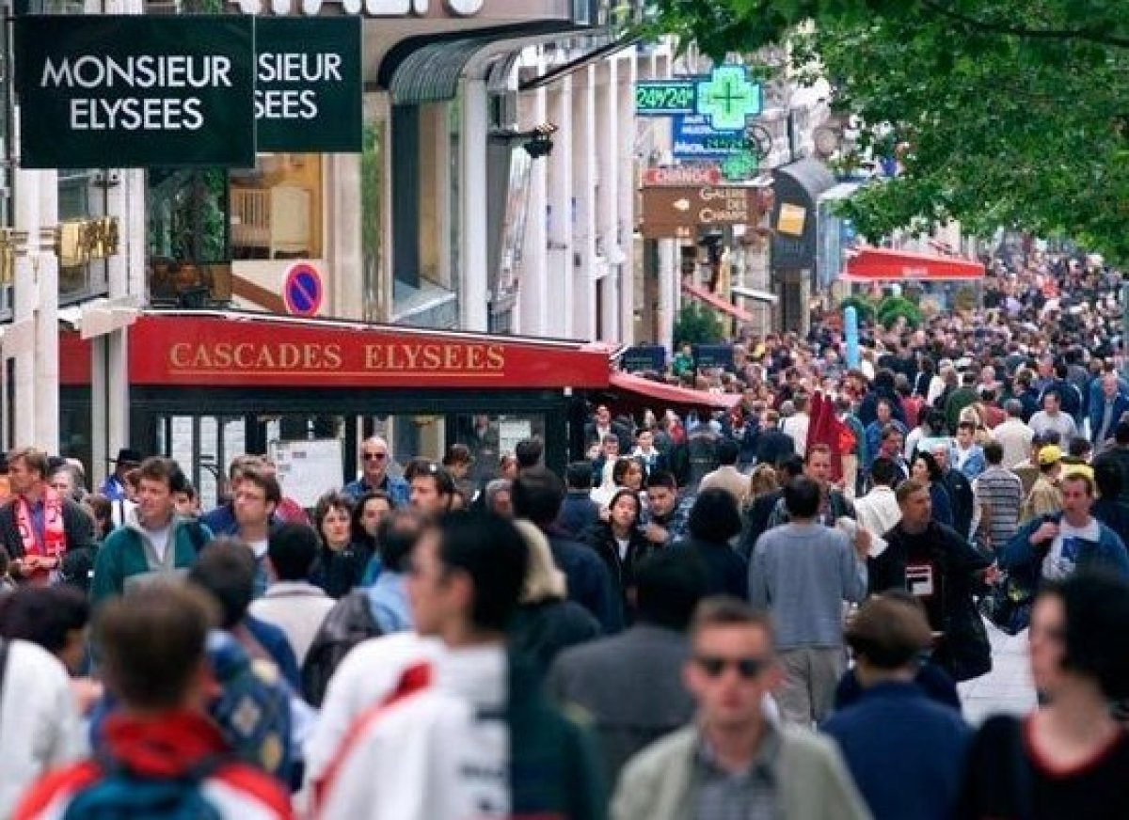
Photo Credit: Casadphoto | Dreamstime.com Though this famous street is still spectacular, especially when viewed from the Arc de Triomphe, its glamour has been tarnished by dealerships, megastores, and overpriced cafés. Though there are some notable exceptions (perfumer Guerlain's superb historic flagship, for one), you'll find mostly chains, and many American ones at that.If you're dying to check out the Levis, Banana Republic, or Abercrombie & Fitch superstores, go for it! If it's a truly Parisian walk you're after, stroll along tree-lined Boulevard Saint-Germain; the Rue des Martyrs, from the heights of Montmartre; along the Canal Saint-Martin; or Les Berges de Seine, a new route along the river, beginning in front of the Musée d'Orsay. With no car traffic to deal with, a stroll along the river offers great, up-close views of many of Paris's best monuments and bridges. Plan Your Trip: Visit Fodor’s Paris Travel Guide
- DON'T STAY INSIDE THE CITY LIMITS

Photo Credit: Kiev.Victor / Shutterstock When booking a trip to Paris, whether it's your first or your 15th, keep in mind that some of France's—and the world's—greatest treasures lie within an hour from Paris. You'll be well rewarded by adding an extra day or two to travel a little farther afield to explore some of these riches. An easy, hour-long train ride from Paris, Chartres cathedral is an absolute must-see, especially now, as it undergoes an astonishing restoration (and to see the cathedral rising up in the distance over the flat countryside is an experience in itself). Besides splendid Giverny, also an hour train ride away, consider Vaux-le-Vicomte orFountainebleau; the Château de Chantilly, with its world-class art collection, Le Nôtre gardens, and famous stables; and the charming medieval town of Senlis, a short taxi ride from Chantilly. Plan Your Trip: Visit Fodor’s Paris Travel Guide
- DON'T WAIT IN LINE AT THE EIFFEL TOWER
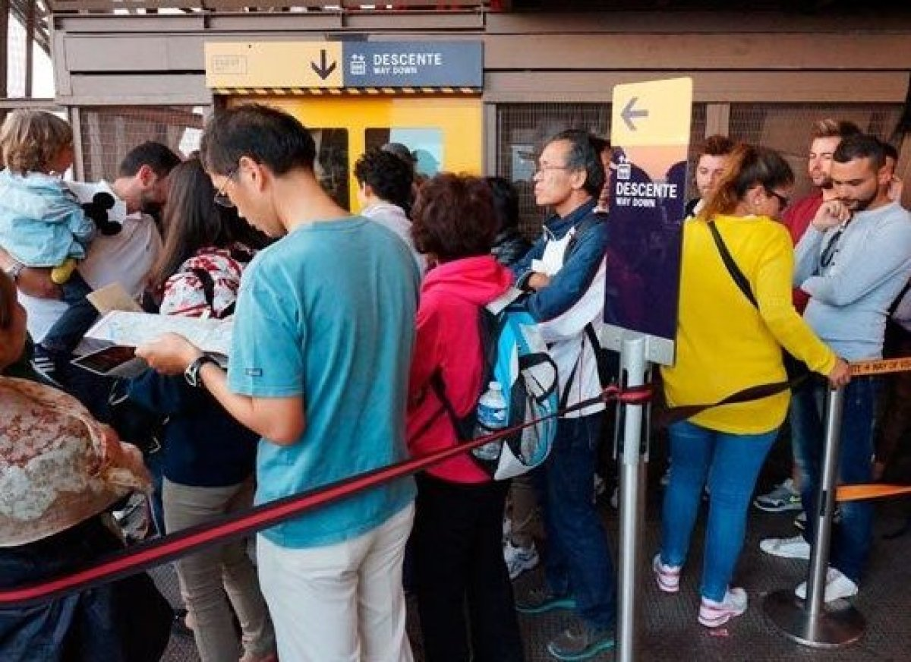
Photo Credit: Shootalot | Dreamstime.com The Eiffel Tower isn't one of the world's most visited monuments for nothing. While you won't want to miss the thrilling ride up and extraordinary views, waiting in long lines is not the ideal way to spend precious vacation time. And you don't have to. Intrepid visitors can walk the 328 steps to the tower's first level and take the lift from there. Many tour companies, likeEasy Pass, offer "skip the line" tours (and you can stick with the tour or not). The time you'll save skirting lines is worth a little extra cash. If money is no object, your very best bet is to book a table at Alain Ducasse's swank Le Jules Verne restaurant on the tower's second floor (3-course lunch, €98; dinner, €185). Along with gorgeous views, you'll dine in splendor and arrive like a VIP on a dedicated lift. Plan Your Trip: Visit Fodor’s Paris Travel Guide
- DON'T BE AFRAID TO EAT LIKE A PARISIAN

Photo Credit: Escargot by Eric Chan CC BY 2.0 Find out what the fuss is about from the source. From garlicky escargots to boudin noir (blood sausage) and tête de veau (calf's brains), the list of French specialties and delicacies is long—and it needn't involve slimy creatures or mysterious parts. Dishes like confit de canard (preserved duck leg) tender lapin (rabbit) or langouste (spiny lobster from the coast of Brittany) are well worth a try. Vegetarians should look for white asparagus, fraises des bois, and any truffle dish they can afford. You might have heard a lot about unpasturized cheeses being dangerous (and too fattening), but the French are the best argument to the contrary. With enough varieties to enjoy a different cheese every day of the year—from cow (vache), goat (chèvre), or sheep (brebis) milk—ask the fromager to give some advice and grab a baguette! Plan Your Trip: Visit Fodor’s Paris Travel Guide
- DON'T BE AFRAID TO GO OFF THE BEATEN PATH
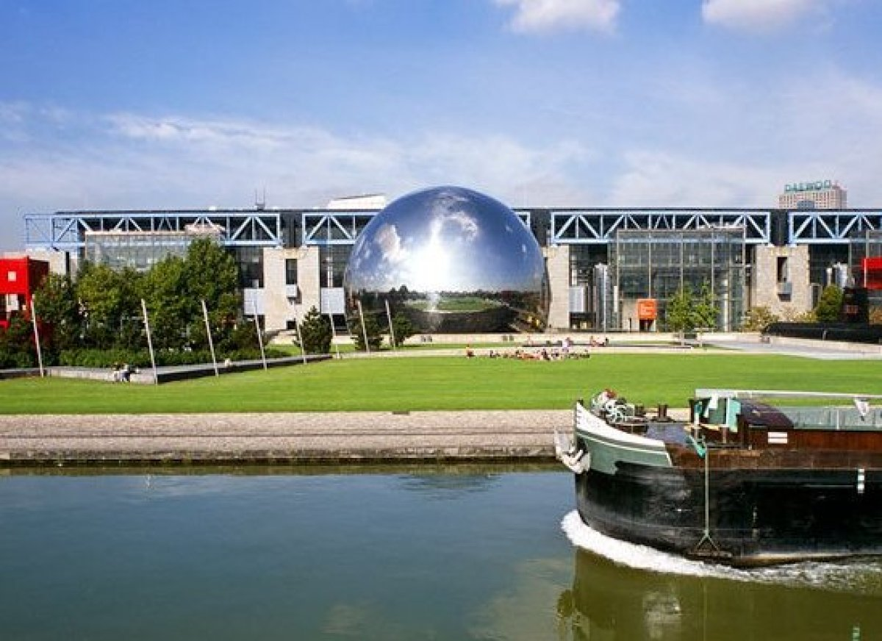
Photo Credit: Paris Tourist Office / Jacques Lebar Paris's parks—both large and small—afford memorable experiences, fabulous views, and outdoor cultural activities galore. The city proper's largest green space, La Villette is more than just a park. Home to Cité de la Musique, Cité des Enfants, and the new Paris Philharmonie, it also borders on the fabulous arts center Centquatre and has tons of summer activities for the whole family. The Bois de Vincennes—and the next door Chateau de Vincennes, France's best preserved medieval chateau—includes the fabulous Parc Floral (see their outdoor concert series), the newly opened zoo, and so much more. Check out the glorious views from lovely Parc de Belleville (20th), and the Buttes Chaumont (19th) is a perennial favorite. As weird as sounds, Paris's cemeteries are wonderful for a historic stroll: Père Lachaise is tops, followed by Montparnasse and Montmartre. Plan Your Trip: Visit Fodor’s Paris Travel Guide
- DON'T RELY ON TAXIS LATE AT NIGHT

Photo Credit: Elena Dijour / Shutterstock You can spend an hour looking and still not find a taxi; and even if you do, you may still get attitude or the runaround from the driver. Unlike New York and other major cities, you can't depend on flagging down a taxi in Paris, and the taxi stand system is maddening and unreliable, even in the daytime. Smartphone car services, like Uber, LeCab, AlloCab, and others operating in Paris, have become an excellent alternative. Increasingly popular (despite semi-successful attempts by taxi drivers to have them legally abolished), they provide fast, reliable service—in English—and are almost unfailingly courteous. And you won't have to worry about the meter ticking away while you pass the same monument for the third time. Plan Your Trip: Visit Fodor’s Paris Travel Guide
- DON'T THINK TOURS ARE TOO TOURISTY
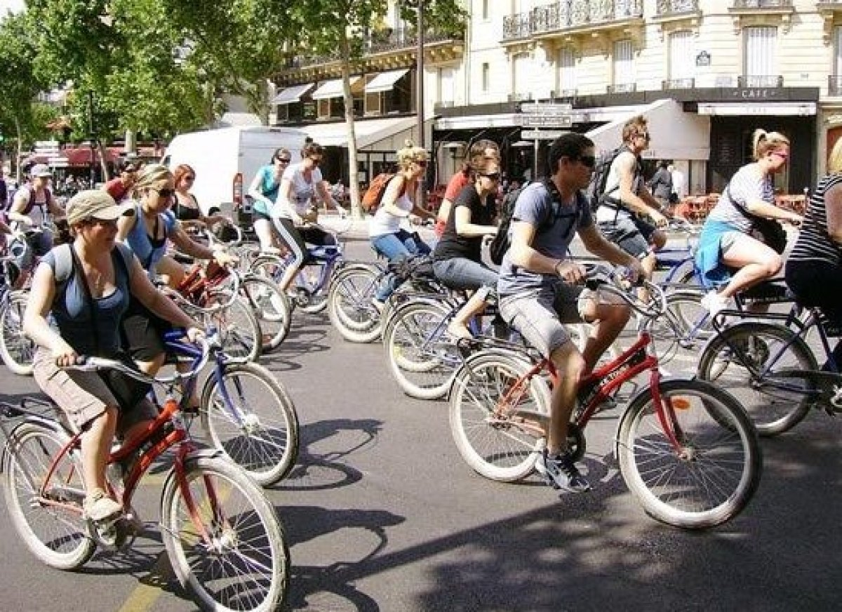
Photo Credit: Paris bicycle tour by Jean-Pierre CC BY-SA 2.0 There are tons of excellent tours—on foot or bicycle—that can show you sides of Paris you may not see on your own, offer insider tips and historical facts, get you through the lines and into VIP places, and enrich your entire experience. For 20 years, Paris Walks has offered a series of enticing strolls, led by friendly, knowledgeable experts, that explore everything from fashion and chocolate to churches, along with specific neighborhoods and historic themes. Underground Paris gives an insider's initiation into Paris's rich street art scene. Bike About has a great range of discovery bike tours, for groups, family, or private groups, in off-the-beaten path neighborhoods, as well as Versailles and the Champagne region. Fat Tire offers day and nighttime bike (or electric scooter) tours in Paris and beyond that gets you through the lines. For more about recommended tours, see Paris's Best Insider Tours. Plan Your Trip: Visit Fodor’s Paris Travel Guide
- DON'T SKIP PRE-TRIP PLANNING
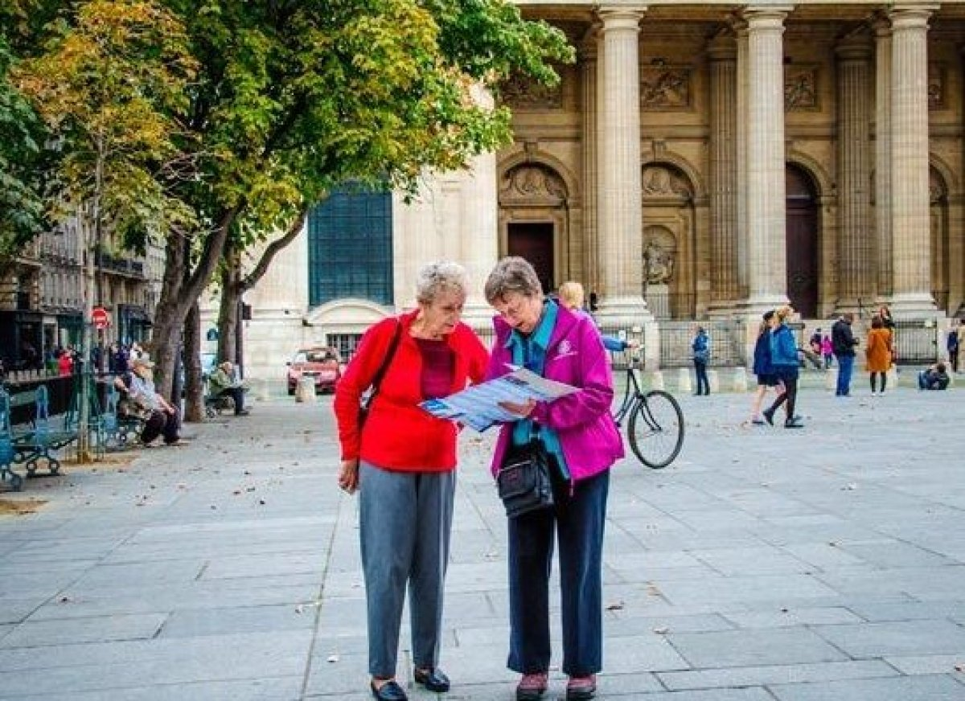
Photo Credit: Larjon | Dreamstime.com Paris is smaller than many major cities, but wandering around the city—an absolute must—can be frustrating if you don't understand its layout and street plans. Familiarize yourself with the arrondissement system and have some idea of the neighborhoods before going, or cram on the plane ride over. Once here, hands down the best investment you'll make is a plan de Paris—a small, inexpensive map by arrondissement (Paris L'Indispensable is a good one, €6.50, at any newsstand) that lists every street, monument, and museum. Don't neglect guidebooks and apps, including French apps in English, like the superb Visit Paris by Metro app (RATP), which offers accurate metro schedules down to the minute and detailed itineraries. The apps can save a lot of time, money, and frustration. Guidebooks can be invaluable for getting the most out of a neighborhood too—and you won't incur roaming charges! Plan Your Trip: VisitFodor’s Paris Travel Guide
- DON'T PASS UP VÉLIB’ RIDES
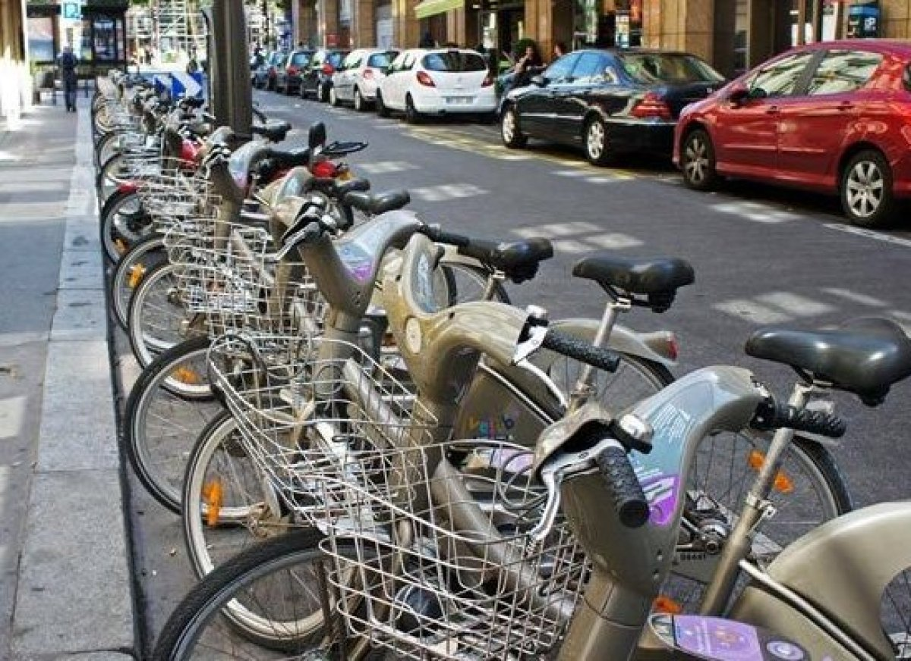
Photo Credit: Vélib' bikesharing station, Paris by mariordo59 CC BY-SA 2.0 Paris's bike-for-hire system Vélib’—for velo (bike) and liberté—is one of the best and cheapest in the world. All you need is a credit card with a chip and you're off. Rentals are easy, stations are everywhere, bike lanes are safe and Paris-wide, and rentals are 24 hours a day, all-year round. Here's how it works: go to the terminal at any Vélib' station; follow the on-screen instructions in English; select your subscription (1-day, €1.70; 7-day, €8) and bike; wait for the green light and go. The first 30 minutes are free, the second half hour is €1, the third costs €2, and every half hour after costs €4. Last June, Paris inaugurated P'tit Vélib,’ for kids ages two to eight (with adorable bikes of the appropriate size), which can be rented at the Berges de Seine, Canal St-Martin, and the Bois de Vincennes. Plan Your Trip: VisitFodor’s Paris Travel Guide
- DON'T LEAVE YOUR KIDS AT HOME
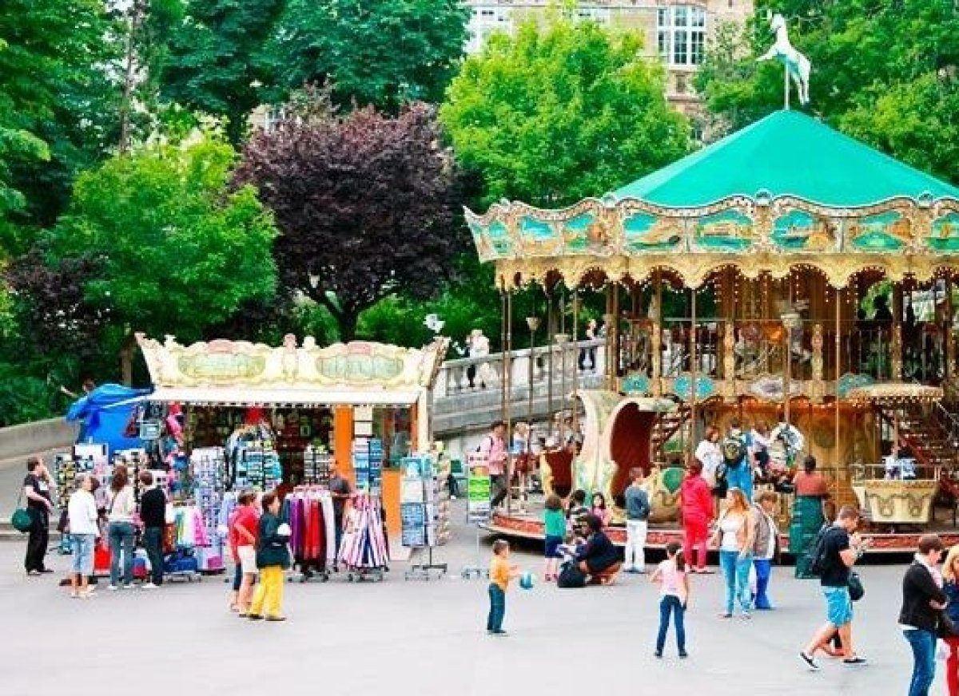
Photo Credit: Nick_Nick / Shutterstock Paris is an amazingly kid-friendly city, and don't let anyone tell you otherwise. If you follow basic rules, you and your kids and will have a great time. For starters, every museum, foundation, arts center, and park in the city has a tantalizing list of activities for kids, some in English. Paris's top hotels—including Le Bristol and Meurice—have added new attractions for kids, including cooking classes and tours, leaving parents some free time to hit the spa. From Guignol puppet theaters, historic merry-go-rounds, playgrounds (theLuxembourg Gardens has all three, for example) to interactive museum exhibits (Muséum d'Histoire Naturelle, Cité des Enfants, Palais de la Découverte) and amusement parks (Jardin d'Acclimatation), your children will be well-entertained during their visit. Plan Your Trip: Visit Fodor’s Paris Travel Guide

