Investigating to build foundation knowledge about Disney theme park attractions.
Special Effects: Audio-Video-Music-Lighting

Coolest Special Effects In Disney World
http://www.buzzfeed.com/cassierose117/15-coolest-special-effects-in-disney-world-fmhg
Posted by Cassie Ryan
Thank you to : http://www.wdwhints.com/2012/07/special-effects-used-within-haunted.html for permission to link and re-print the article below.

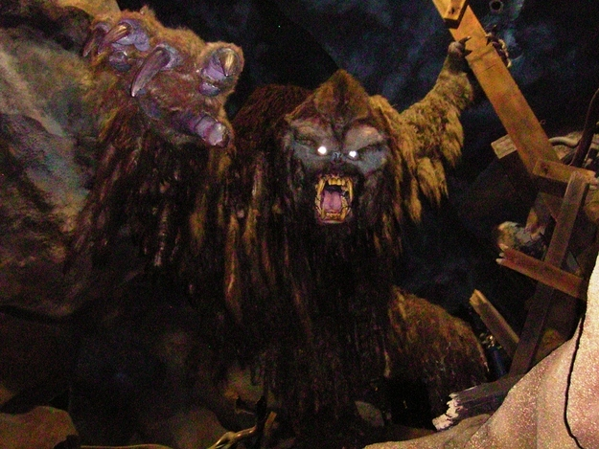
Expedition Everest
Expedition Everest in Disney’s Animal Kingdom takes guests on a Himalayan adventure in search for the legendary Yeti! At almost 4 minutes long, this thrilling roller coaster includes it’s own animatronic Yeti that terrifyingly claws and growls at riders as they zip by! Scary!

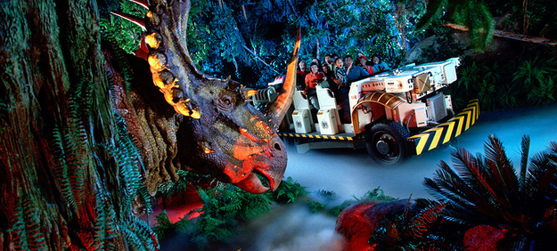
Dinosaur
Animal Kingdom takes guests back into the Cretaceous era to find some dinosaurs! In special time rovers, guests encounter over 10 super realistic (and super scary) animatronic dinos!
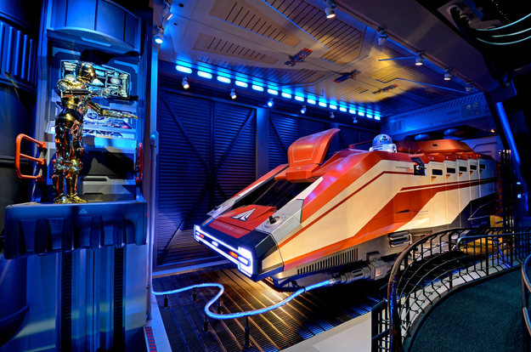

Star Tours
Hollywood Studios’ Star tours takes guests on their very own spaceship to explore the world of the Star Wars films! Using flight simulation and projections, C-3P0 leads the way through space, and every time you ride the journey is different!

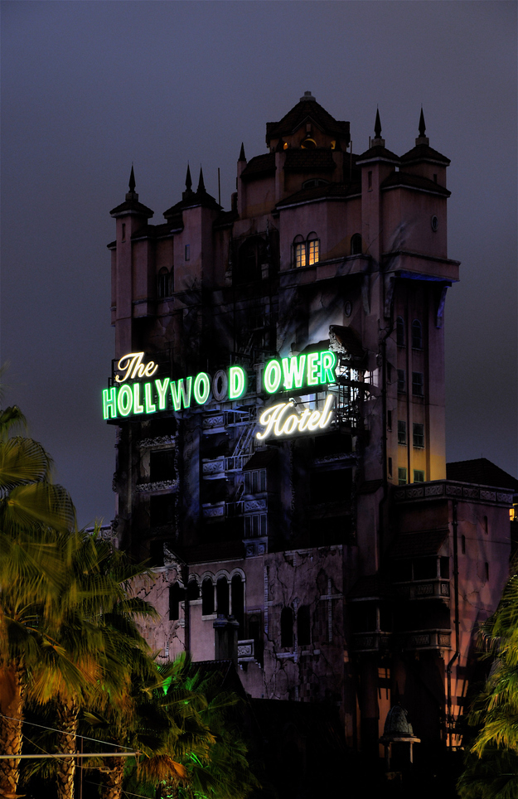
The Twilight Zone Tower Of Terror
Disney’s most magical hotel isn’t The Grand Floridian, it’s Hollywood Studios’ Hollywood Tower Hotel. When lightning strikes the tower, guests are taken into the 5th dimension with some of the most advanced technology around! Before that famous drop, projections and mirrors are used to create some super creepy effects!

Mission: SPACE
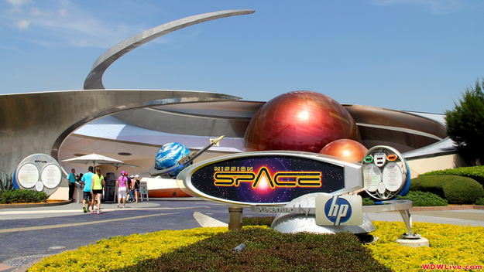
When Disney puts barf bags right in front of your seat, you know something cool is about to happen! EPCOT’s Mission: SPACE simulates space travel in a human centrifuge, spinning guests so fast, they feel weightless.
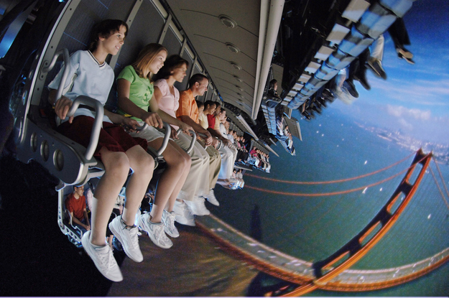

Soarin’
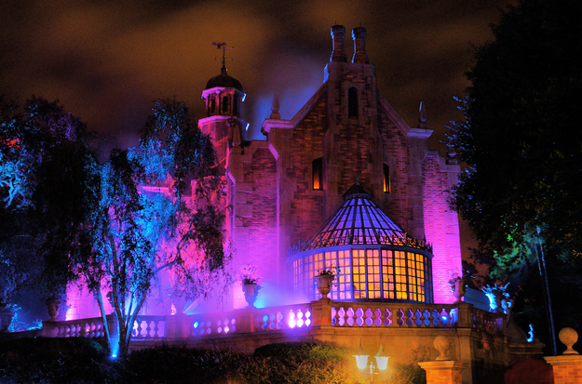
EPCOT’s Soarin’ is a high flying adventure that takes guests over the most beautiful sights in California, including Disneyland of course! This flight simulator uses a huge projection screen, blowing wind, and even smells to send guests straight into Cali!

The Haunted Mansion
From hitchhiking ghosts, to singing busts, to (not?) stretching paintings, The Magic Kingdom’s Haunted Mansion is full of special effects! From classic animatronics to modern high-tech projection technology, The Haunted Mansion’s 999 happy haunts leave guests amazed!

